**MS Excel: Data Visualizations**

**Gráficos de barras**

Los gráficos de barras muestran **datos categóricos** mientras que los histogramas muestran datos numéricos. **Cada barra muestra el recuento de cada categoría**.

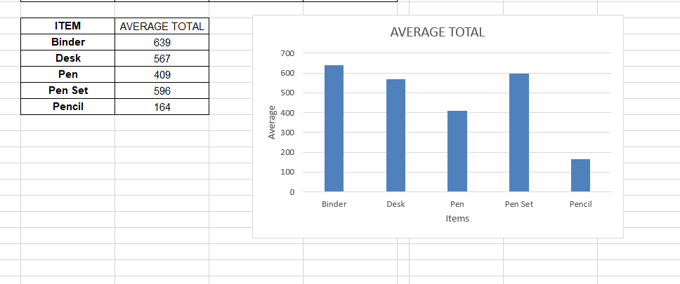

**Gráficos de barras**

Los histogramas son excelentes gráficos para una visión simplificada de la distribución de un conjunto de datos. Separamos los datos en contenedores y luego graficamos el recuento en cada contenedor.

* **FÓRMULA FREQUENCY()**

[link](https://exceljet.net/excel-functions/excel-frequency-function)

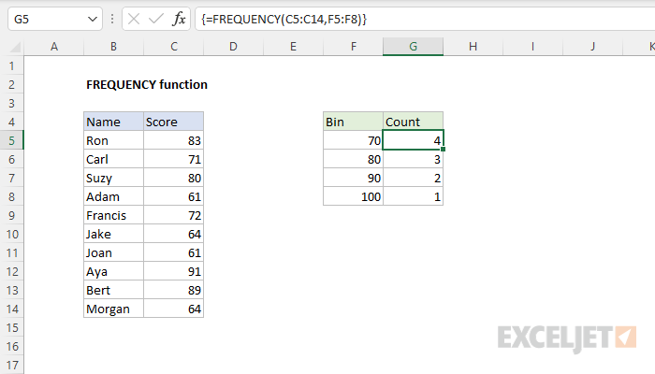

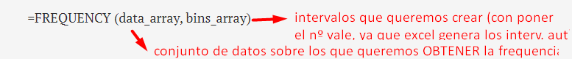

**Nota: Si toma la suma de la columna Frequency, debería sumar el número total de puntos de datos en el conjunto de datos** .

→ En el siguiente ejercicio si hacemos dicha suma se ve que hay 43 líneas de datos

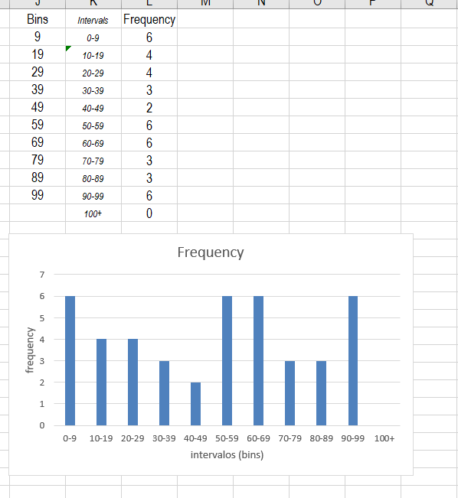

* **FÓRMULA COUNTIF()**

[link](https://support.microsoft.com/en-us/office/countif-function-e0de10c6-f885-4e71-abb4-1f464816df34)

Para contar el número de celdas que cumplen un criterio; por ejemplo, para contar el número de veces que una ciudad en particular aparece en una lista de clientes.



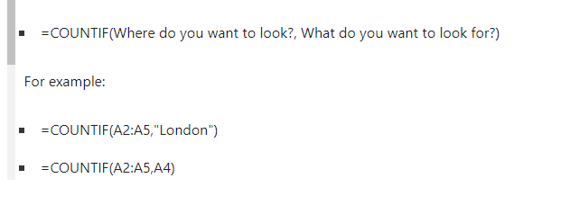

| Data | Data |
| --- | --- |
| apples | 32 |
| oranges | 54 |
| peaches | 75 |
| apples | 86 |
| Formula | Description |
| --> =COUNTIF(A2:A5,"apples") | Counts the number of cells with apples in cells A2 through A5. The result is 2. |
| --> =COUNTIF(A2:A5,A4) | Counts the number of cells with peaches (the value in A4) in cells A2 through A5. The result is 1. |
| --> =COUNTIF(A2:A5,A2)+COUNTIF(A2:A5,A3) | Counts the number of apples (the value in A2), and oranges (the value in A3) in cells A2 through A5. The result is 3. This formula uses COUNTIF twice to specify multiple criteria, one criteria per expression. You could also use the COUNTIFS function. |
| --> =COUNTIF(B2:B5,">55") | Counts the number of cells with a value greater than 55 in cells B2 through B5. The result is 2. |
| --> =COUNTIF(B2:B5,"<>"&B4) | Counts the number of cells with a value not equal to 75 in cells B2 through B5. The ampersand (&) merges the comparison operator for not equal to (<>) and the value in B4 to read =COUNTIF(B2:B5,"<>75"). The result is 3. |
| --> =COUNTIF(B2:B5,">=32")-COUNTIF(B2:B5,">85") | Counts the number of cells with a value greater than (>) or equal to (=) 32 and less than (<) or equal to (=) 85 in cells B2 through B5. The result is 3. |
| --> =COUNTIF(A2:A5,"*") | Counts the number of cells containing any text in cells A2 through A5. The asterisk (*) is used as the wildcard character to match any character. The result is 4. |
| --> =COUNTIF(A2:A5,"?????es") | Counts the number of cells that have exactly 7 characters, and end with the letters "es" in cells A2 through A5. The question mark (?) is used as the wildcard character to match individual characters. The result is 2. |